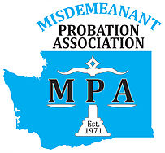
MPA GROUP MEMBERSHIP FORM
Washington State Misdemeanant Probation Association
MPA Tax ID # 91-1254334

 6-10 Employees $200

Date: __________________________________________  11+ Employees $375

Organization
Street Address
City/State/Zip
County
Phone
FAX
Department Head
Email
Jurisdictions Served

Please fill out the following for each MPA member.
Name | Email | Member of MPA Since

Attach an additional sheet if necessary.

Membership is good for one year in the calendar year that it is paid.

.
Example:
If you pay in January of 2021, your membership is valid until December 31, 2021.
If you pay in November of 2021, your membership is valid until December 31, 2021.

Please fill out form, include a check payable to MPA and mail to:

Mindy Breiner, MPA Treasurer
Tukwila Municipal Court
15005 Tukwila International Blvd
Tukwila, WA 98188

