JUNE 7, 2018
MPA QUARTERLY
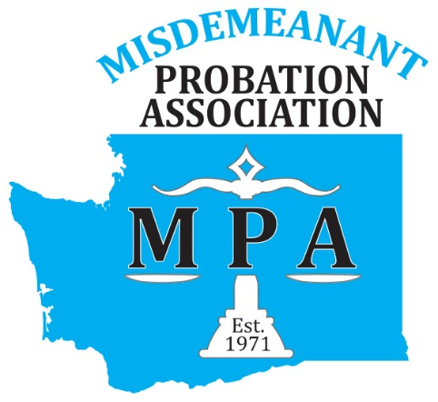

Upcoming Events
July 15-21, 2018
Pretrial, Probation and Parole Supervision Week

July 16
MPA Board Meeting
CJTC-Burien 10a-2p

July 29

APPA 43RD ANNUAL TRAINING INSTITUTE-PHILADELPHIA
September 10-21, 2018
2018 Probation Academy
SAVE THE DATES!
2019 MPA CONFERENCE
Marcus Whitman Hotel
Walla Walla, WA
May 6-8, 2019!
More information to come in the next newsletter!

WWW.WA-MPA.ORG
Congratulations to our newest board members who officially join the board this July:

Vice-President-Tony Farris, Skamania County
Secretary-Camille Jackson, Lynnwood Municipal
Membership-Omar Gamez, Edmonds Municipal
Legislative-Rebecca Partington, Snohomish County
Education/Training-Melissa Patrick, Des Moines Municipal
UPDATES
- Those speakers who provided a presentation for release are available on the MPA website. As well as conference ceu certificates.
- Walla Walla Probation is looking to host a DV MRT training course in October. To express interest or for more information please contact Ashley Kulberg.
- Do you have an area of expertise in the probation realm that you would like to share with academy attendees? Numerous subject matter aficionados are needed to make each academy spectacular. Contact Mindy Breiner for more information or to volunteer.
- Is there a specific topic or speaker you would be interested in hearing at a regional training or the annual conference? Share your thoughts with your education/training co-chairs! Melissa Patrick or Jim Smallwood!
- Are you interested in getting more involved with MPA? Join us for a board meeting or contact incoming president Chris Hornung and share your desire to do more! Committee positions often arise or need for additional help!

