NOVEMBER 5, 2018
MPA QUARTERLY
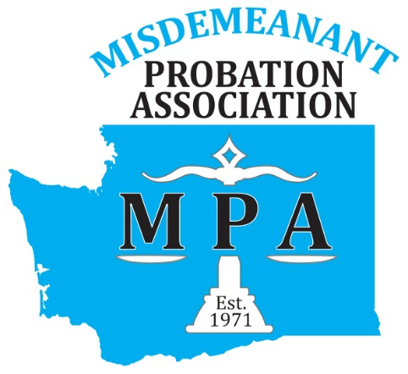

Upcoming Events
January 2, 2019
MPA Membership forms and Conference Registration Forms available online! Look for online payment methods in 2019!
January 28, 2019
Winter Board Meeting Ellensburg 10a-2p ALL Welcome!

March 10-13, 2019
APPA Winter Institute-Miami

March 27-28, 2019

DUI Court Refresher-Beaverton, OR
May 6-8, 2019
MPA Annual Conference
The Marcus Whitman Walla Walla
September 18-20, 2019
4th World Congress on Probation-Sydney Australia

WWW.WA-MPA.ORG
Congratulations to our recent
Probation Academy Graduates:
Maria B.-Yakima; Andy C.-Lewis; Kris C.-Grant ; Effran D.-Pierce; Jason D.-Yakima; Lindsey D.-Snohomish; Maria F.-Bothell; Matt G.-Mason; Yolanda G.-Pasco; Amy H.-Clark; Mark H.-Pierce; Michelle L.-Clark; Rachel L.-Clark; Stephanie M.-Everett; Alex M.-Snohomish; Aaron N.-Pierce; Dawn R.-Pierce; Angela S.-Snohomish; Derek S.-Lakewood; Rene S.-Island; Paige S.-Bothell
UPDATES
- Thanks to DMCJA who provided our organization with funding, we will be welcoming Keith Graves of Graves and Associates as our Highlighted Speaker-addressing “Emerging Drug Trends”.
- The board would like to announce the appointment of Tonya Dotson from Seattle Municipal Court as the new Legislative Chair. Her term will expire in 2020.
- 52 participants successfully completed Motivational Interviewing hosted by MPA in Des Moines in October!
- 30 probation officers and court staff completed the DV MRT training hosted by SnoCo in September. A list of probation departments who are or will be offering the class to outside referrals can be found here.
- As of July 1, 2018 DSHS is no-longer the monitoring agency for behavioral health providers, due to legislative changes DOH is now responsible. The links to the new WACs and changes can be found here.
- Are you interested in getting more involved with MPA? Join us for a board meeting or contact MPA President Chris Hornung and share your desire to do more! Currently, we are looking for someone who would like to take on Public Relations! Contact Chris for more information!

