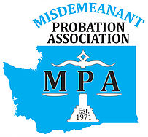
2024 MPA GROUP MEMBERSHIP FORM
Washington State Misdemeanant Probation Association
MPA Tax ID # 91-1254334

 6-10 Employees $200  11+ Employees $375

Organization
Street Address
City/State/Zip
County
Phone
FAX
Department Head
Email
Jurisdictions Served

Please fill out the following for each MPA member.
Name | Title | Phone # | Email

Attach an additional sheet if necessary.

Online payments may be made at: https://www.wa-mpa.org/shop Please make sure to still send in the completed membership form to ensure our directory is kept up to date.

To pay by check, please fill out form, include a check payable to MPA, and mail to:

Mindy Breiner, MPA Treasurer
Tukwila Municipal Court
15005 Tukwila International Blvd
Tukwila, WA 98188

