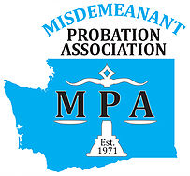
2024 MPA INDIVIDUAL MEMBERSHIP FORM
Washington State Misdemeanant Probation Association
MPA Tax ID # 91-1254334

Professional Member ($40.00) ☐ Renewal ☐ New
Those employed in a Court or government organization, such as officers, counselors, clerks, and court coordinators.
Associate Member ($10.00) ☐ Renewal ☐ New
Limited to students, retirees or those outside government.

First Name
Last Name
Title
Organization
Street Address
Address (cont)
City/State/Zip
County
Work Phone
FAX
Email
Jurisdictions Served
Mark the appropriate categories  in which you are interested in  helping out, if needed? |  |  Legislative   Membership   Education   Newsletter
Number of years in probation
Member of MPA since

Membership is good for one calendar year.

Online payment is available at: https://www.wa-mpa.org/shop Please make sure to still turn in a completed membership form so our directory stays up to date.

To pay by check, please fill out form, include a check payable to MPA, and mail to:

Mindy Breiner, MPA Treasurer
Tukwila Municipal Court
15005 Tukwila International Blvd.
Tukwila, WA 98188

